Date:16.02.2022

**Third Year B. Tech., Sem VI 2021-22**

**Advanced Database System Lab**

**Assignment submission**

**PRN No: 2019BTECS00064**

**Full name: Kunal Santosh Kadam**

**Batch: T2**

**Assignment: 5**

**Title of assignment: Web-based Online Multiple-Choice Tests System**

Design and implement a system for managing online multiple-choice tests.

The system should support distributed contribution of questions by teaching

assistants, editing of the questions by whoever is in-charge of the course and

creation of tests from the available set of questions. It should be able to

administer the tests online, either at a fixed time for all students or at any time

but with a time, limit from start to finish and give students feedback on their

scores at the end of the allotted time.

**Note: The system should allow to give exam from mobile device also**

**Technology stack: Go Language / MySQL or Oracle/ Bootstrap v5.0, look and feel UI template**

Requirement Specifications:

1. User management at different levels (Teachers/students)
2. Question Bank Entry form with provision of accepting images /mathematical expressions
3. Generic report generation: Should able to display/list any data.

Ans:

Starting of MySQL and Apache Modules on XAMPP Control Panel

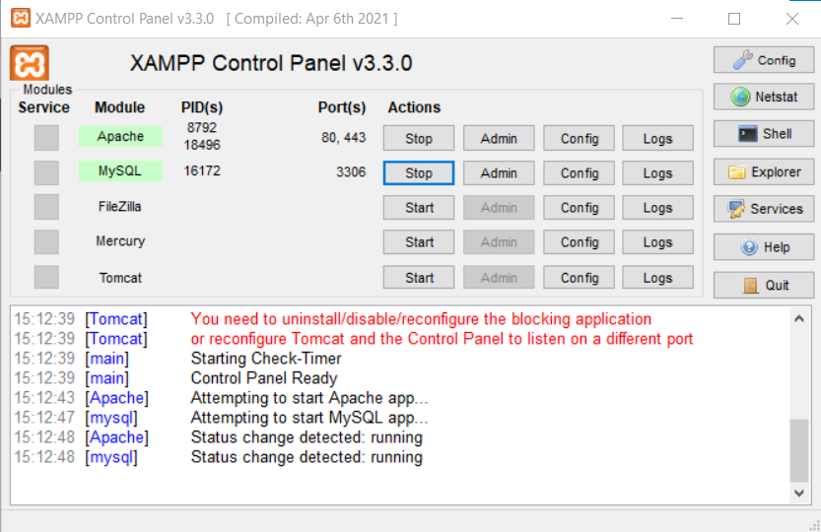

Database Created

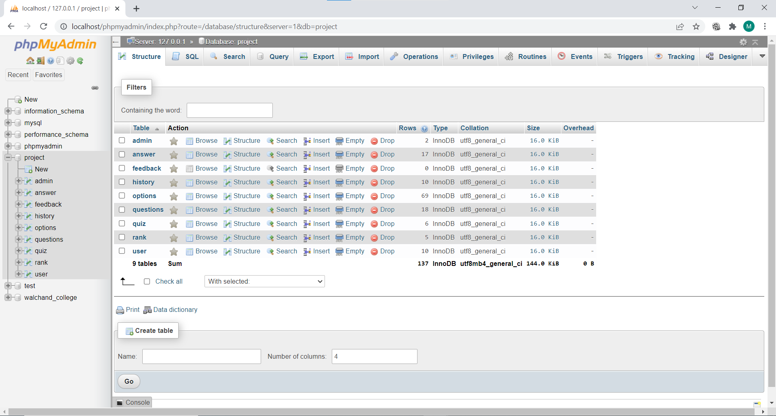

Coding

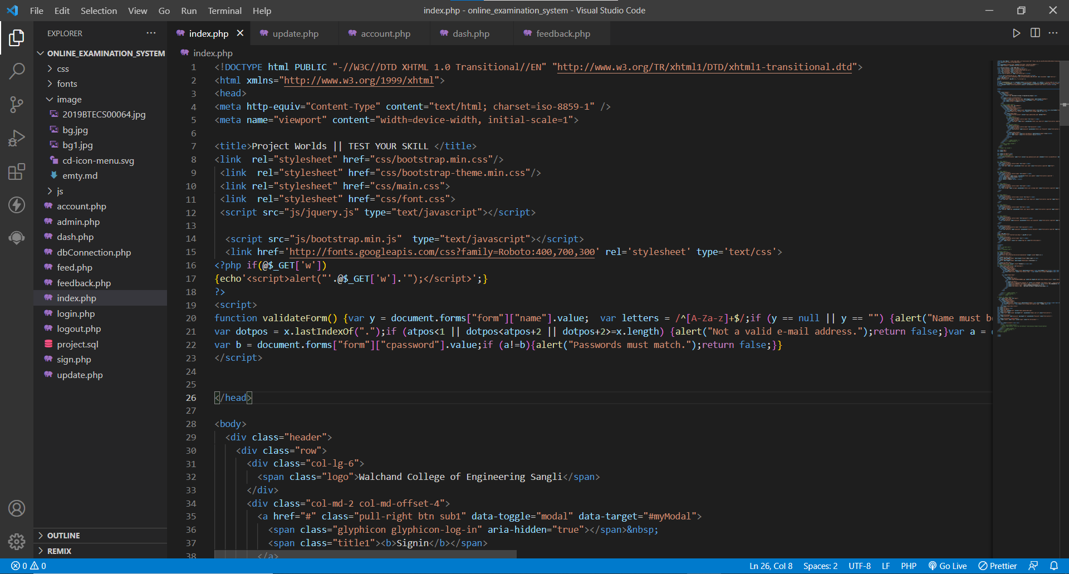

Homepage

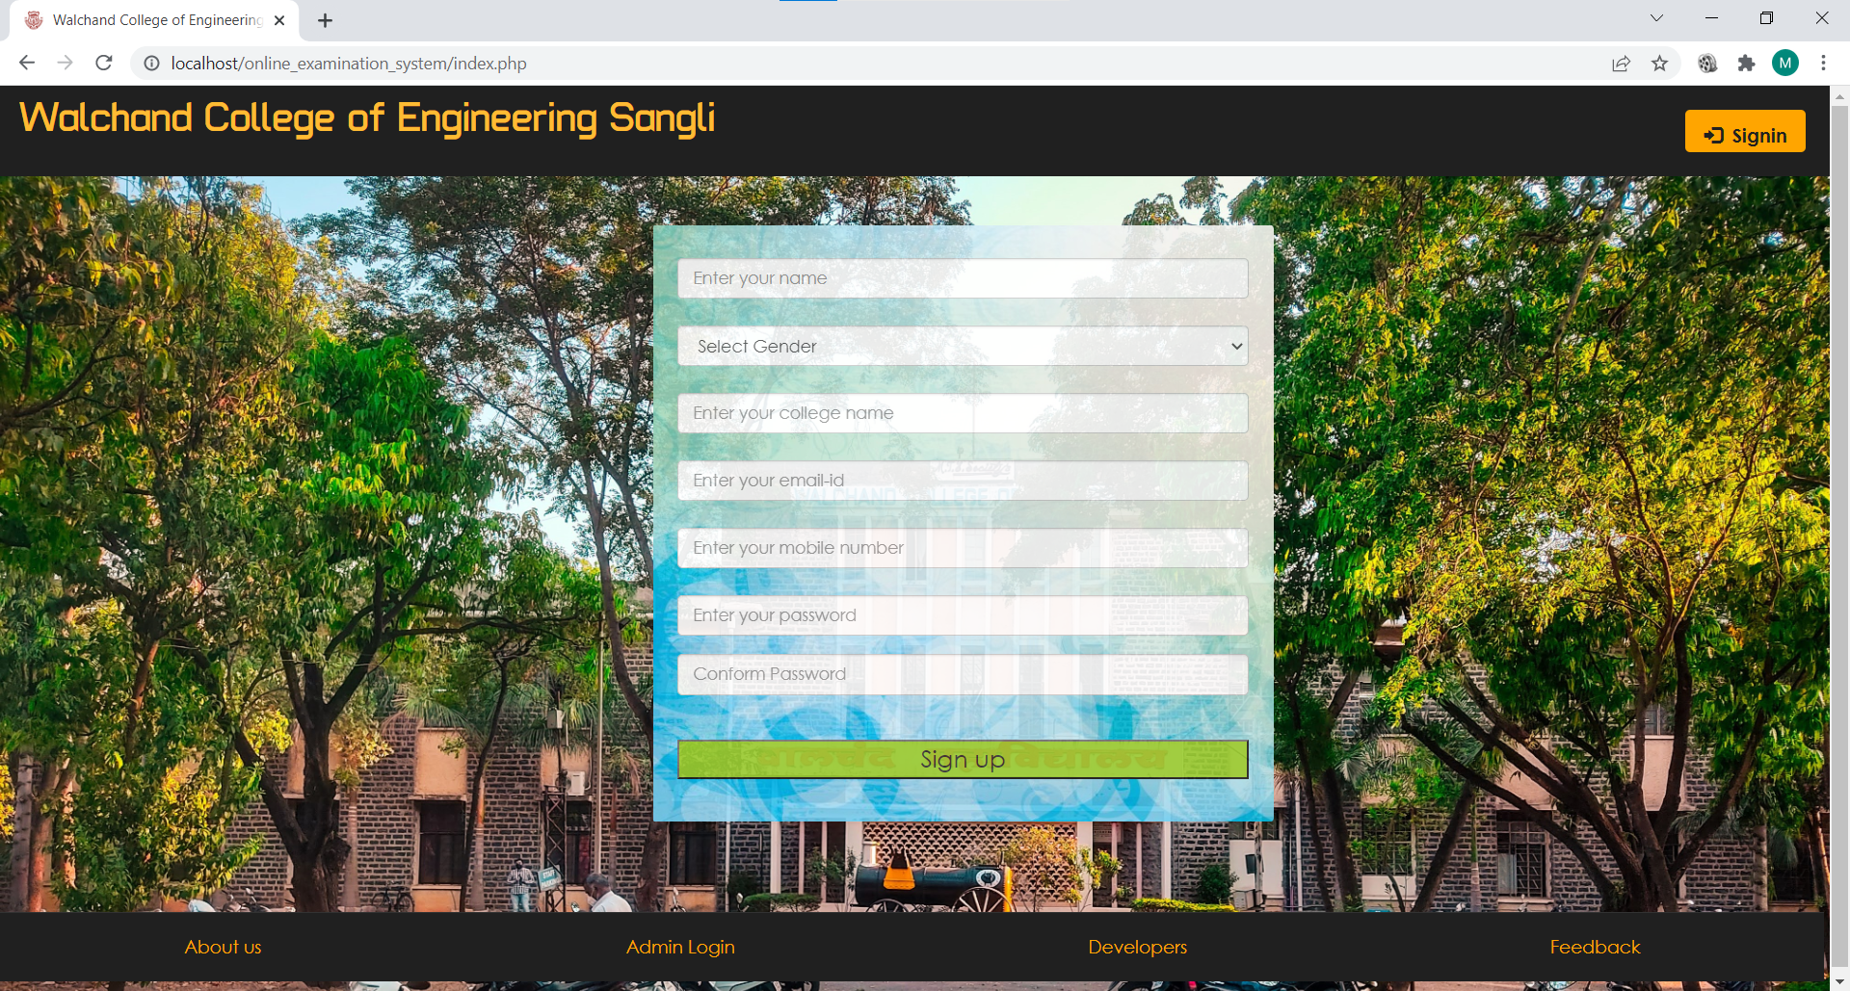

Login Page

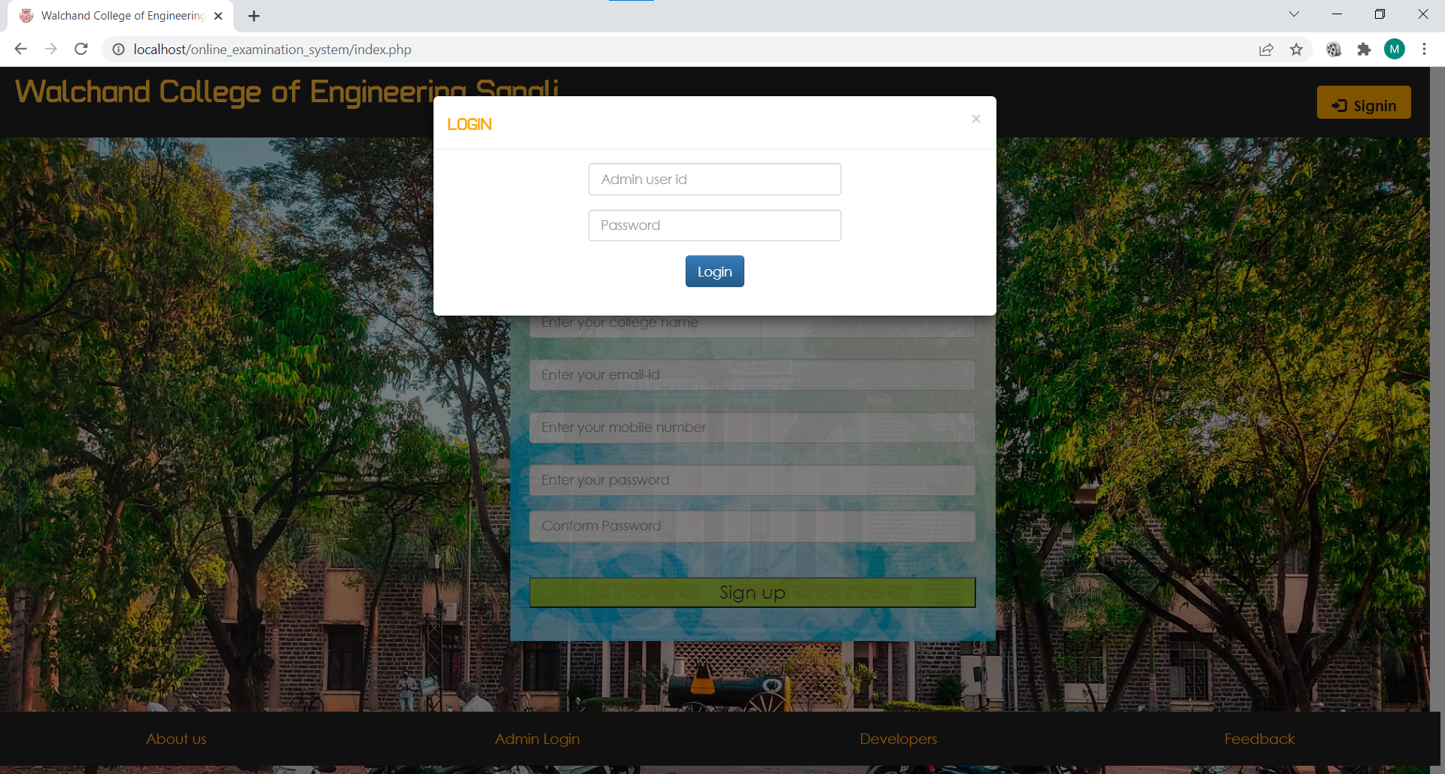

Admin Page

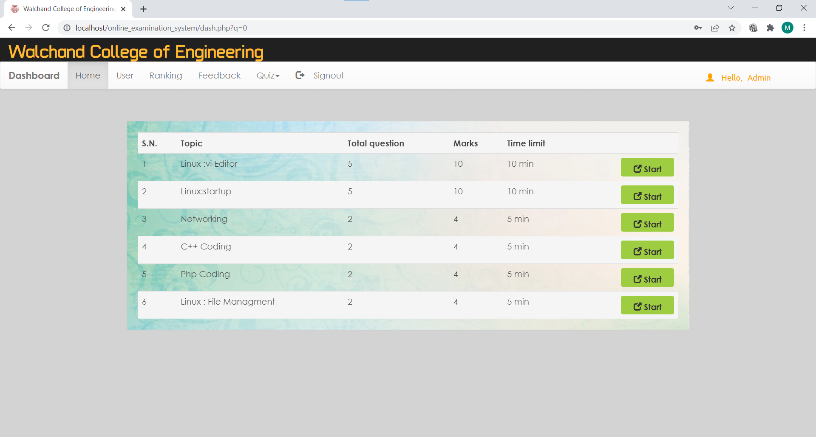

Admin: Student Attempted Page

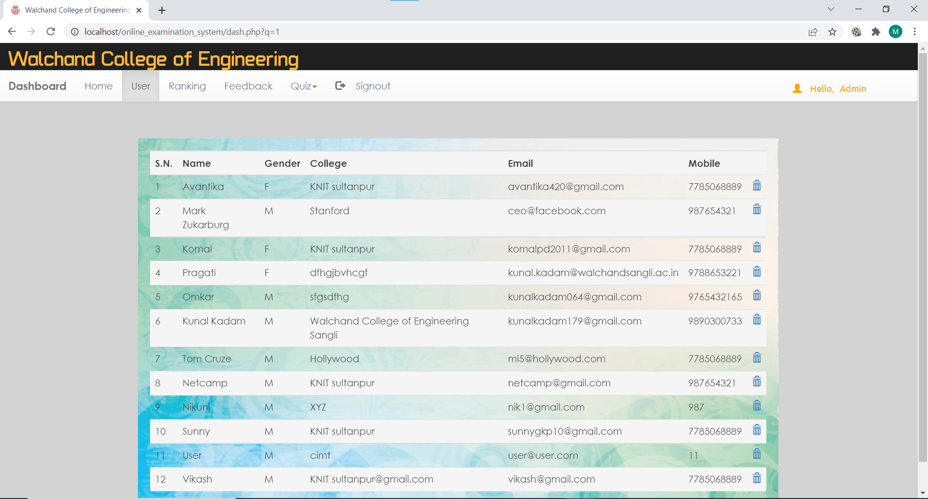

Admin: Ranking Page

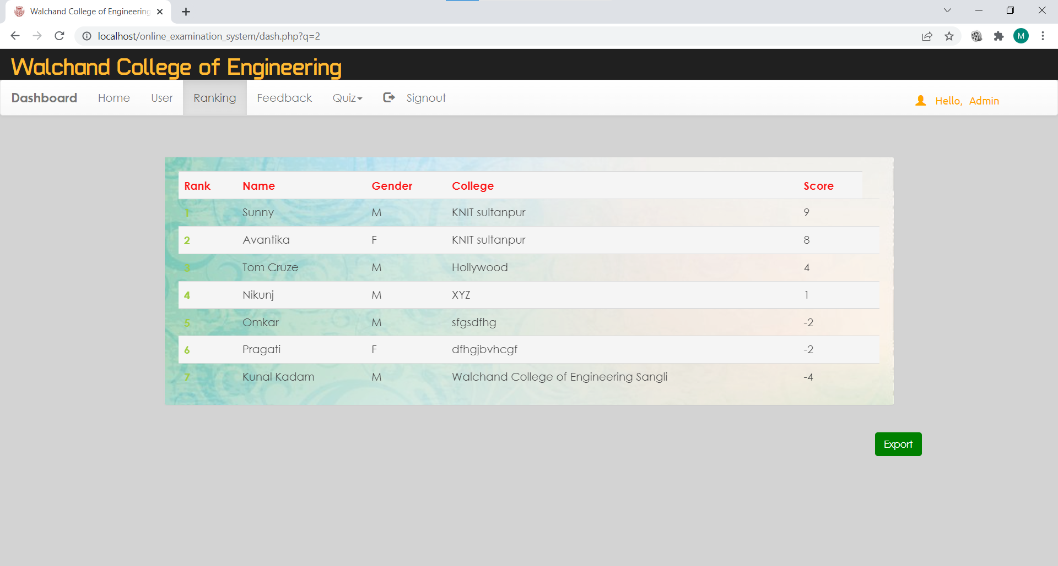

Admin: Feedback Page

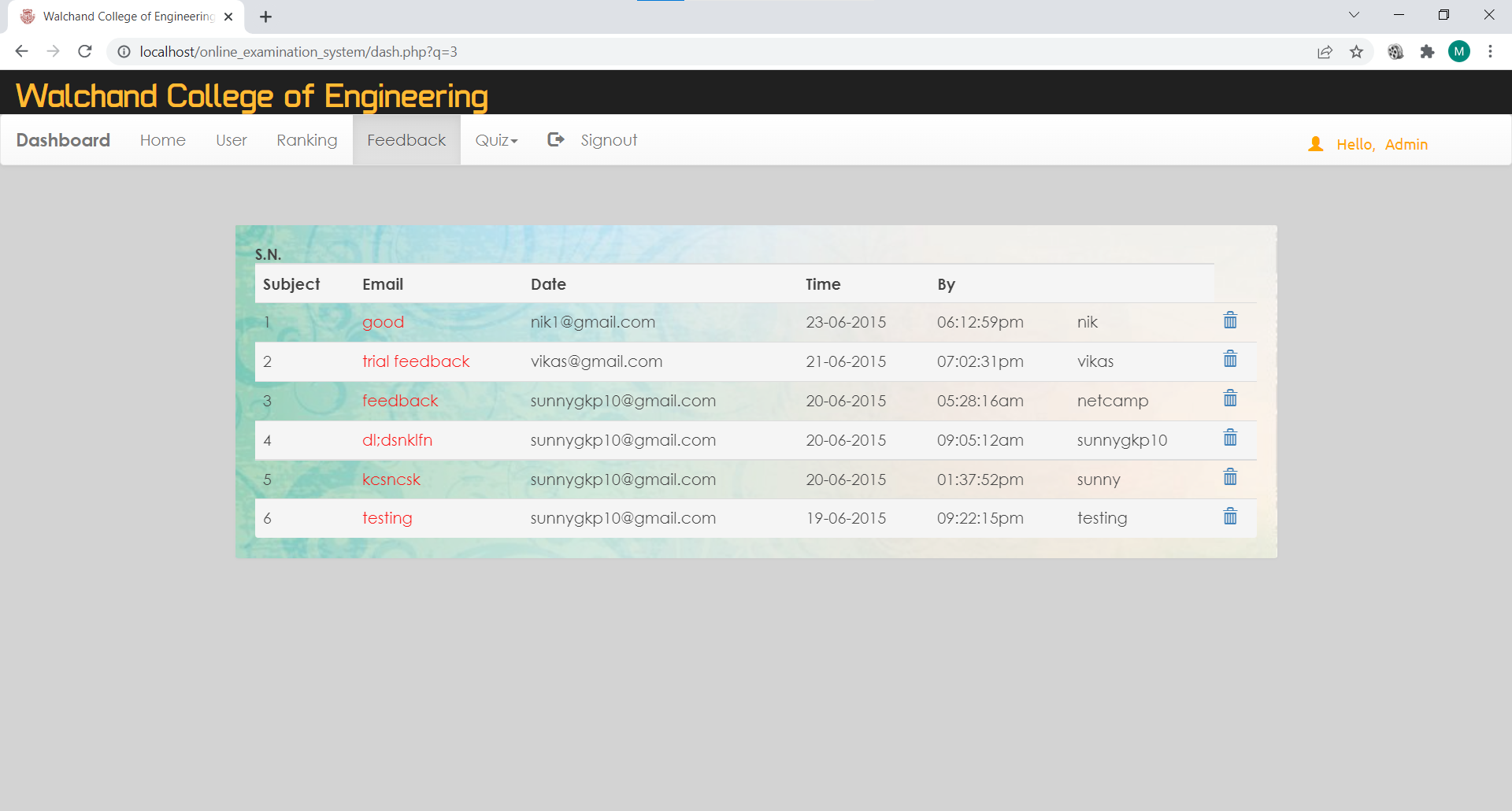

Admin: Add Quiz Page

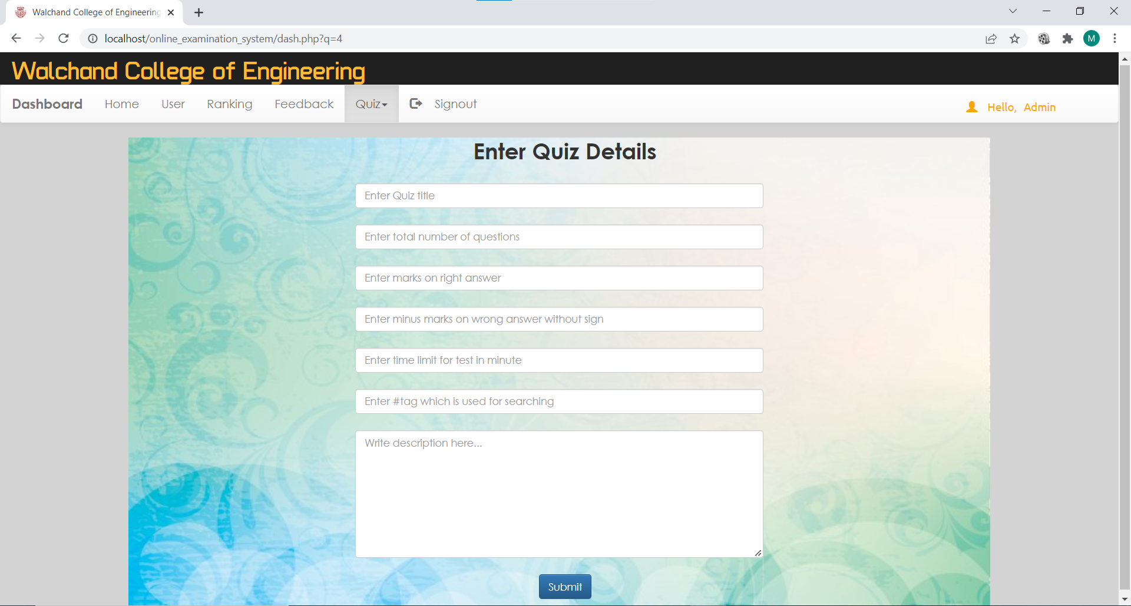

Admin: Question Adding Page

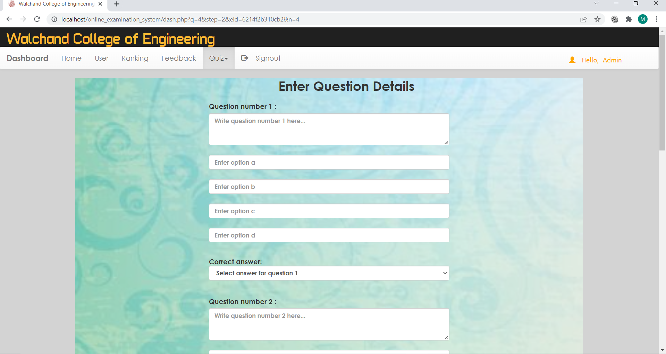

Student Dashboard Page

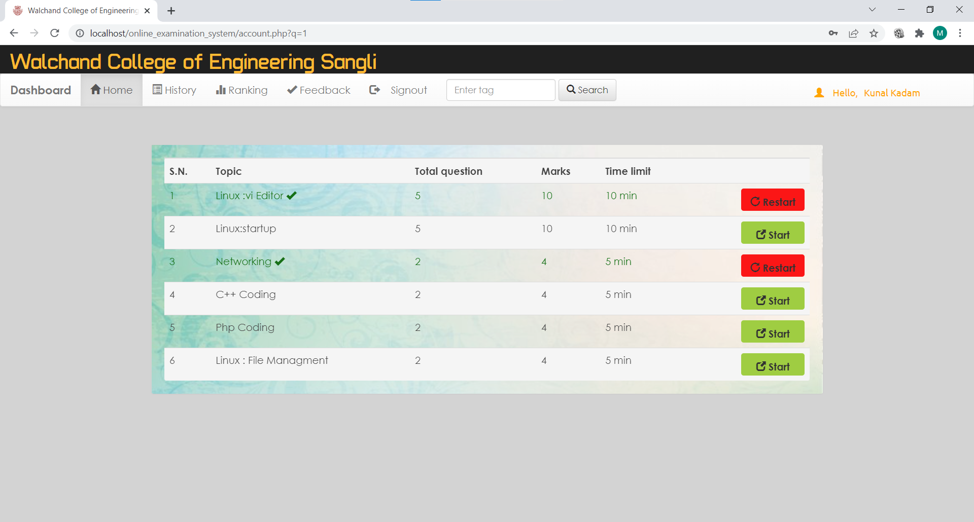

Student: History Page

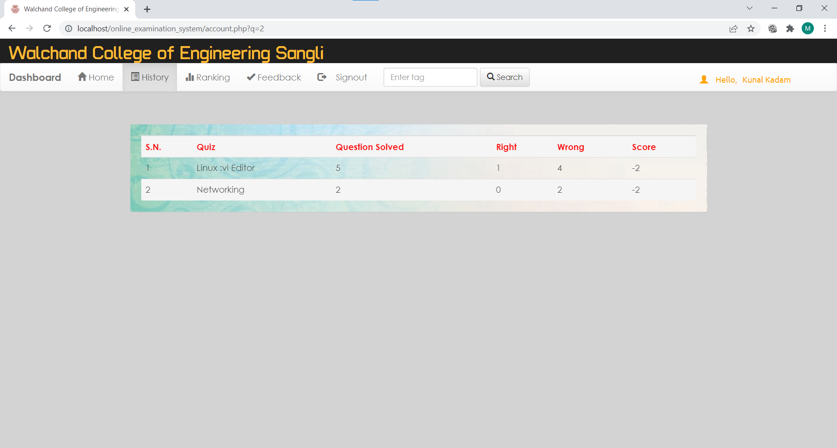

Student: Ranking Page

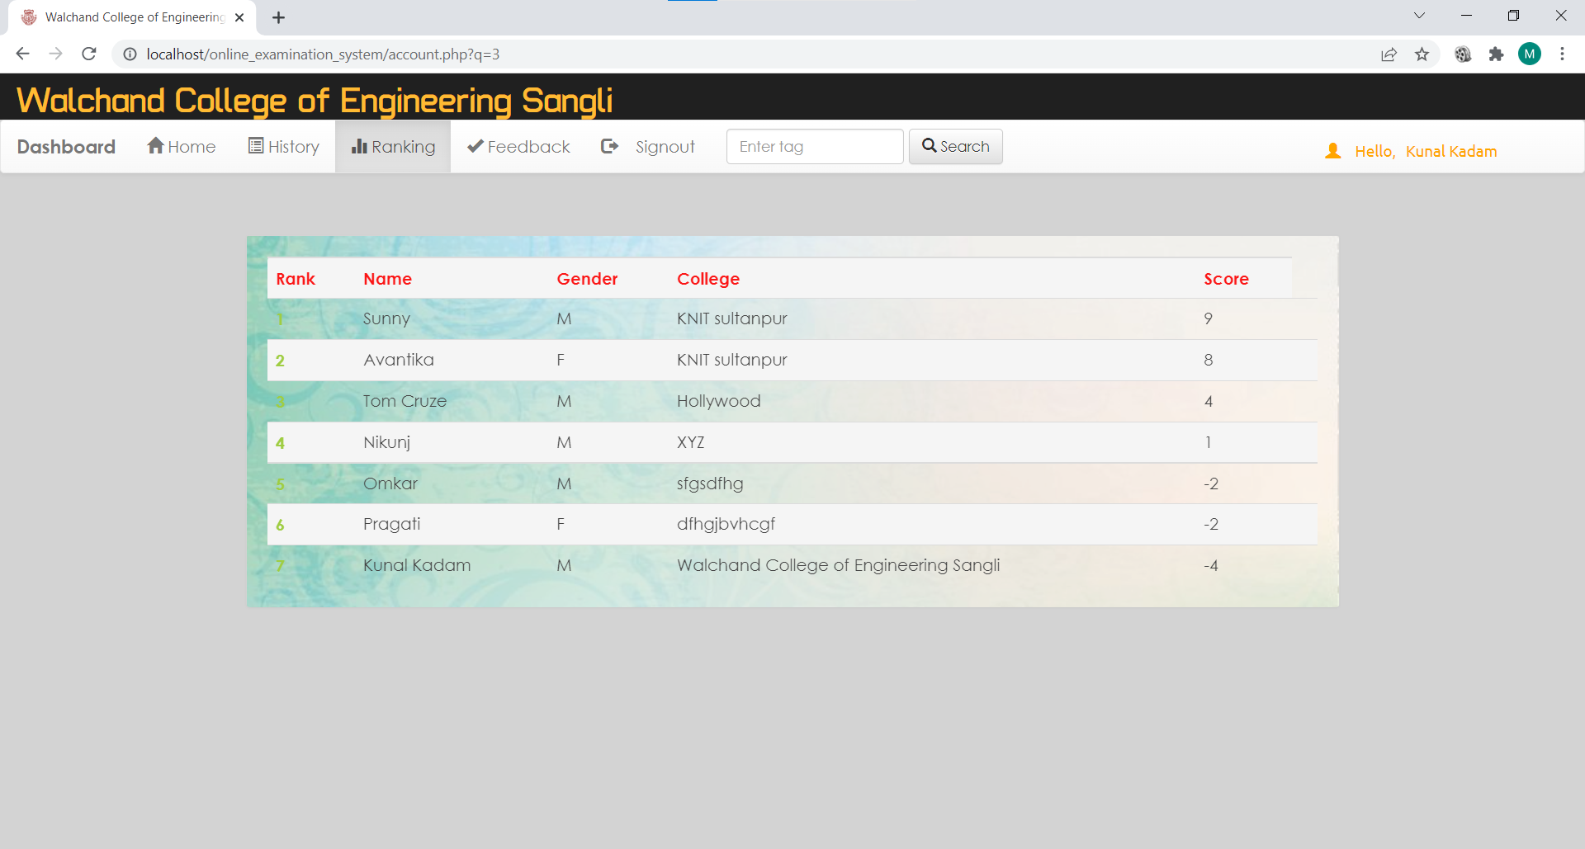

Student: Quiz Question Page

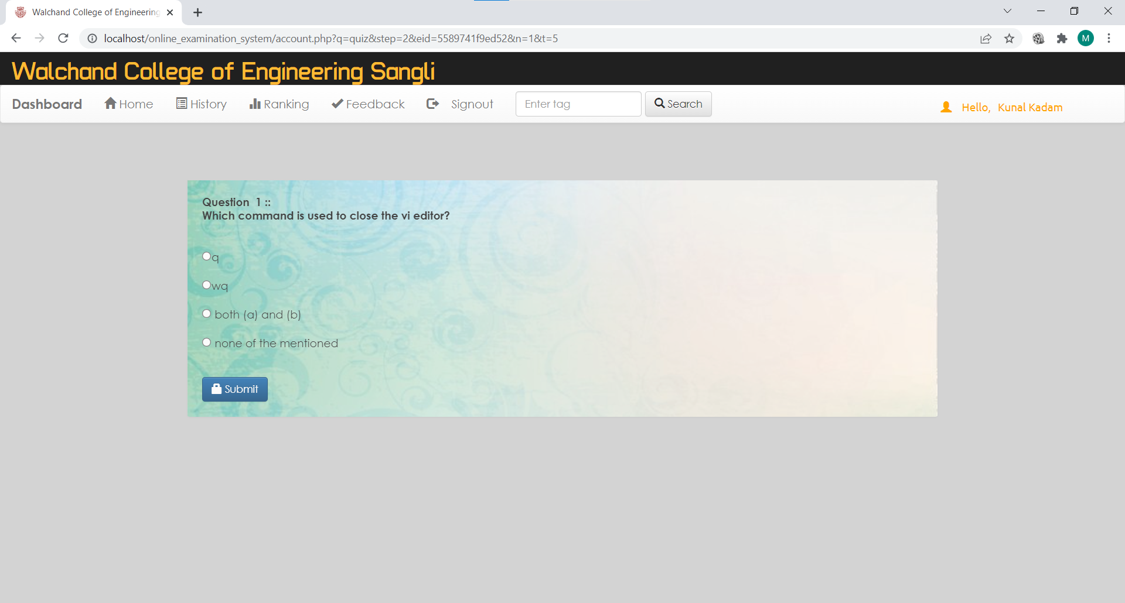

Student: Result Page

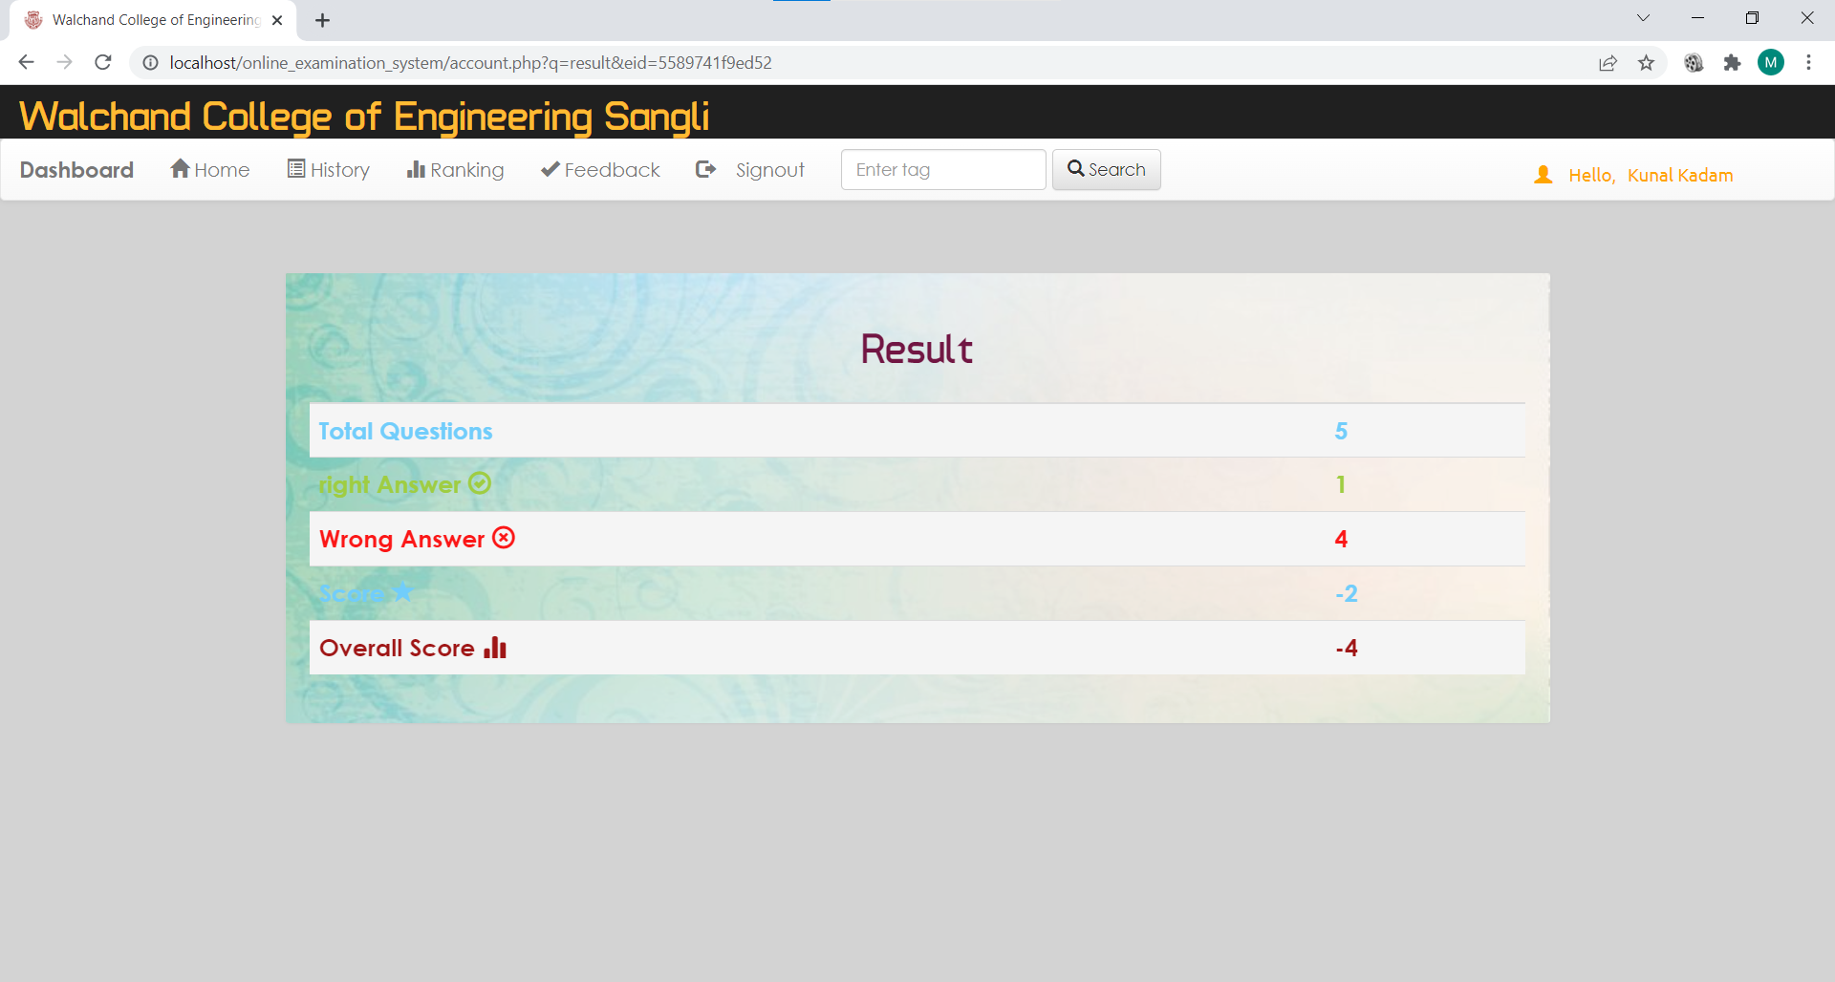

Feedback Page

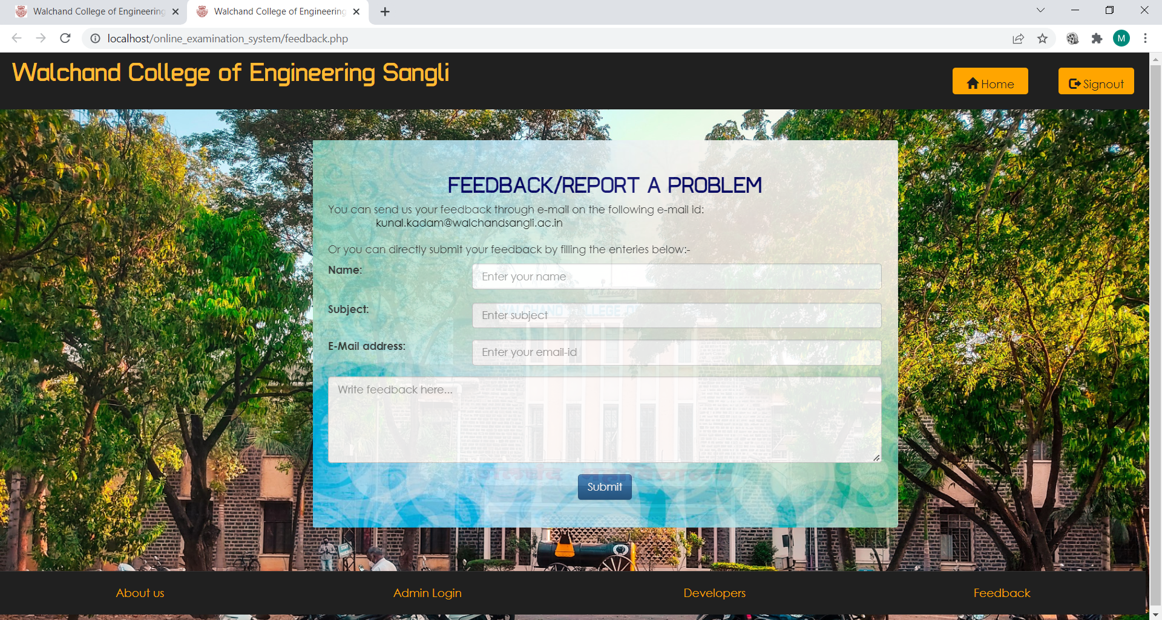

Developer Page

